In case you are using the latest version of “Class Library” project, you can notice the following issues:

* you cannot add reference to .Net DLLs and System.Windows.Form and MessageBox are red

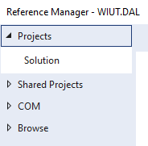



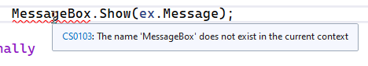

* there is no Settings tab in the project properties:

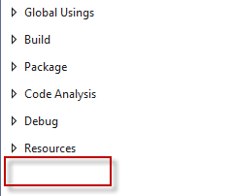

In order to resolve it, perform the following steps:

* Right-click your DAL project and select “Edit Project File”

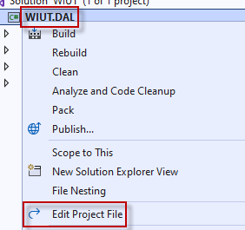

* Change the first line to be

<Project Sdk="Microsoft.NET.Sdk.WindowsDesktop">

* Add the following line inside <PropertyGroup> tag

<UseWindowsForms>true</UseWindowsForms>

End result should look like the picture on the right:

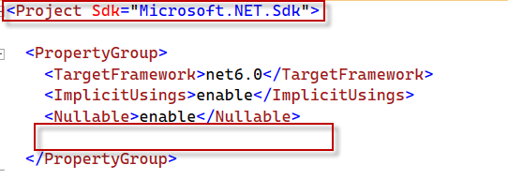 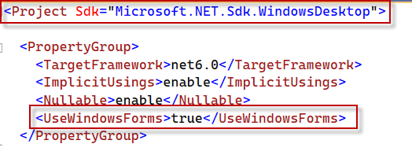

* Right-click your DAL project and select Properties

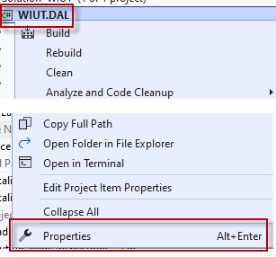

* Select Windows as your target OS:

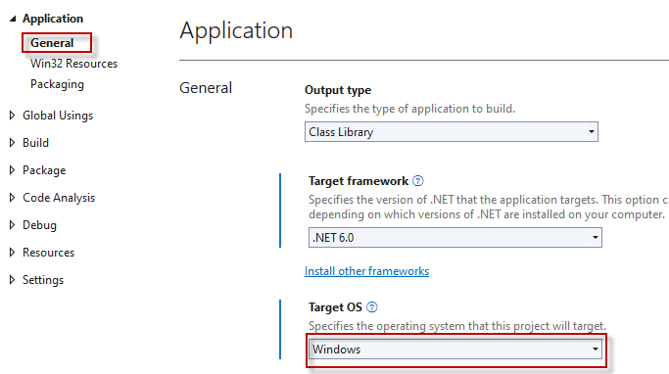

Make sure to save everything and reload Visual Studio. After that all issues should be resolved.